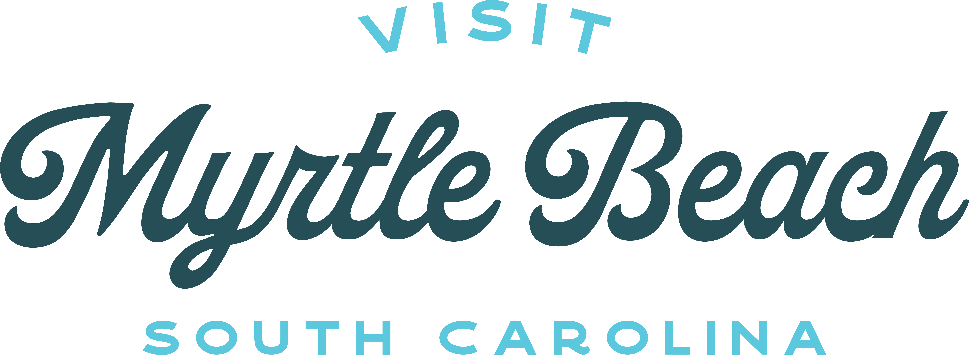

Visit Myrtle Beach to Launch New Reality TV Show, Chef Swap at The Beach
Celebrity Chef Amanda Freitag to Helm the Show Featuring Incredible Restaurants and Culinary Talent Across the Grand Strand

Myrtle Beach, S.C. (August 29, 2022) – Visit Myrtle Beach has partnered with The Workshop Content Studios to develop Chef Swap at The Beach, a new cooking competition television series that will highlight the culinary talents of chefs throughout the Grand Strand. As host and judge, Chef Amanda Freitag will pull chefs out of their resident kitchens and swap them into each other’s restaurant to prepare a new dish for evaluation by a panel of judges. Chefs will not know which kitchen they’ll be in or what they’ll be preparing – an appetizer, entrée or dessert – but they will, however, be able to take one ingredient with them.

Chef Swap at The Beach will premier on The Cooking Channel on October 1, 2022 at 7 p.m. Eastern. The fast-paced 30-minute show will run for a series of six episodes airing on consecutive Saturday nights until early November. Chef Amanda will be joined by judges Johanna Wilson Jones, a Myrtle Beach-based food writer and culinary connoisseur, and Dylan Foster, chef and owner of Two Sons Seafood, in selecting the winning chef and dish for each episode.

“From beachside spots and fresh seafood markets to international cafes and fine dining, Myrtle Beach is a culinary destination unlike any other with over 2,000 restaurants offering tried-and-true favorites next to innovative new flavors. The culinary experiences are just like The Beach – full of flavor, welcoming and ready for any craving,” said Karen Riordan, president and CEO, Visit Myrtle Beach. “Partnering with The Workshop Content Studios and Amanda Freitag along with our resident culinary experts Johanna and Dylan to bring The Beach to a new audience is integral to our efforts in showcasing the Grand Strand’s exciting restaurant scene.”

Throughout the Chef Swap at The Beach series, Chef Freitag and her fellow judges will visit 12 amazing Grand Strand restaurants: 44 & King, Big Mike's Soul Food, Bistro 217, Bonfire-a Smokin Taqueria, Ciao, Drift, Hook & Barrel, Johnny D's, Perrone's, Sea Captain's House, Tidal Creek Brewhouse, and Winna's Kitchen. Chef pairings and menu categories will be revealed in each episode so fans will have to watch to see the competition unfold!

“The chefs in Myrtle Beach really know how to rock their kitchens and bring the heat when it comes to creating new dishes that drive flavors up a notch,” said Chef Freitag. “It’s tough to cook in someone else’s kitchen so Chef Swap at The Beach takes that pressure, adds in the suspense of competition and even gets to the emotion of why these chefs pour their best into their menus. Every episode is filled with fast-paced, heart-tugging drama.”

Known for her work both on and off the TV screen, Chef Freitag has been a judge on Food Network’s Chopped and has appeared on Iron Chef America, Next Iron Chef, Unique Eats, Beat Bobby Flay, and Guy Fieri’s Tournament of Champions, to name a few. She’s on a mission to make cooking more approachable through her cookbook The Chef Next Door. Most recently, she launched a digital series called Easy AF, where she shows audiences that delicious food can be fun, easy, and quick to make right in your home kitchen.

Rounding out the Chef Swap at The Beach judging panel, Johanna Wilson Jones has traveled up and down the Grand Strand tasting the foods that make Myrtle Beach restaurants hum with diners, becoming an expert on the region’s flavors. Johanna is also the host of the Finding our Flavor YouTube series where she highlights the ingredients, foods and dishes that make Myrtle Beach unique. Completing the show’s judging trio is Chef Dylan Foster who offers cooking classes and seafood delivery right from the waters of the Grand Strand’s Murrells Inlet. Chef Dylan also hosts the YouTube series On the Hook exploring the people, places and tales of Myrtle Beach seafood on and off the boat.

For more on Chef Swap at The Beach including behind-the-scenes show photos, featured restaurant locations, chef tips and more on the destination’s culinary scene, visit www.chefswap.com.

About Myrtle Beach, S.C.
Myrtle Beach isn’t just a beach. It’s The Beach. Popularly known as the Grand Strand, Myrtle Beach is one destination made up of 14 unique communities that stretch 60 miles along the northeast coast of South Carolina. Families, couples and those in search of a warm welcome will find more than just a day at The Beach when they come together to connect and enjoy vibrant entertainment and family attractions, including world-class golf, shopping and fresh coastal Carolina cuisine. From the moment you arrive, you’ll find you belong at The Beach – Myrtle Beach, South Carolina. For additional information on tourism offerings in the Myrtle Beach area, visit www.visitmyrtlebeach.com or call (888) Myrtle-1.
###

Editor’s Note: Visual assets for the Chef Swap at The Beach show are available https://visitmyrtlebeach.box.com/v/ChefSwapatTheBeachMediaAssets

Media Contact:
Kimberly Miles
Fahlgren Mortine
843-655-7902
mbteam@fahlgren.com

